**[](https://www.ayabank.com/wp-content/uploads/2020/01/MIUuniversity.png)Myanmar Imperial University (MIU)**

No.(1), Zay Myauk Road, Phayargyi Ward, Dagon Township, *Yangon* (Near U-Wisara Round about)

Phone no : 09 73210001, 09 421100222

[https://www.facebook.com/myanmarimperialcollege/](https://www.facebook.com/myanmarimperialuniversity/?__tn__=%2Cd%2CP-R&eid=ARAX18eiAdPpbZO9ygNxAd5xY-0LjzM0x4oHxK-aFFCwnijfxYzSuCaqtI8NSsOnOLmX7ku54g3ZZ8Fr)

**[](http://www.ayabank.com/wp-content/uploads/2016/11/00.png)**

**Myanmar Institute of Business(MIB)**

104, First Floor, Myanmar Center (HAGL), Kabaraye Pagoda Road, Bahan Township Yangon, Myanmar.

Phone no : 09 453300600

<https://www.facebook.com/MIBeducation/>

[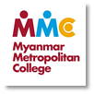](http://www.ayabank.com/wp-content/uploads/2016/11/0.png)

**Myanmar Metropolitan College (MMC)**

47/48 Bahosi Building, Lanmadaw Tsp 11131,Yangon.

Hotline: 0926333 4223/4/5/6, 09 4500 63108/9

[www.yourmmc.com](http://www.yourmmc.com)

[](https://www.ayabank.com/wp-content/uploads/2020/01/strategyfirst.png)

**Strategy First University (SFU)**

No.8, Panchan Tower, Bargayer Road, Myay Ni Gone,San Chaung Township, Yangon.

Phone no : 09 250 7171 66-68.

[https://www.facebook.com/Strategyfirstinstitute/](https://www.facebook.com/StrategyFirstUniversity/)

**[](https://www.ayabank.com/wp-content/uploads/2020/01/crowneducation.png)Crown Education**

No. 275, 3rd floor, Pyay Road, Yangon, Myanmar

office : +95(1) 527838

Mobile : +95(9) 65085185

[https://www.facebook.com/crowneducation](https://www.facebook.com/crowneducation/)

[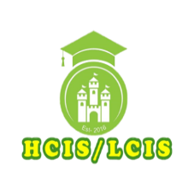](https://www.ayabank.com/wp-content/uploads/2020/03/hcislcis.png)  
**HCIS / LCIS**

Ma 7/13 , 62 street, Between Theik Pan Road and Padauk Road (357.31 mi)

Phone no : 02 284 7629

[https://www.facebook.com/littlecambridgepreschool](https://www.facebook.com/littlecambridgepreschool/?epa=SEARCH_BOX)

[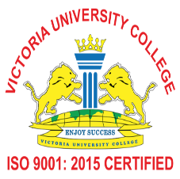](https://www.ayabank.com/wp-content/uploads/2020/03/victoriauniversity.png)

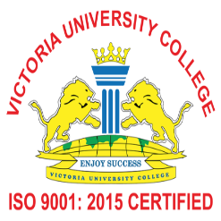**Victoria University College**

City Campus, 166, Upper Pansodan Street, Mingalar Taung Nyunt Township, (0.87 mi)

Phone no : 01 383 133

<https://www.facebook.com/vucedu/>

**[](https://www.ayabank.com/wp-content/uploads/2020/07/LBU-Logo-2.png)**  
**London Business Academy, Mandalay**

64 Street, Between 31 Street & 32 Street, Chan Aye Thar Zan Township, Mandalay

Hotline – 09 765000016, 09 765000017

<https://www.facebook.com/LBAMandalay/>

**[](https://www.ayabank.com/wp-content/uploads/2020/07/inet-word-logo.png)iNet College**

66A Street, Between TheikPan Street x 43rd Street, Mandalay

Hotline : 02 2832610

<https://www.facebook.com/iNetCollegeMyanmar/>

**[](https://www.ayabank.com/wp-content/uploads/2020/07/British-university-college.jpg)British University College**

S-25, U Chit Maung Housing, U Chit Maung Road, Yangon

Phone No : 01 401272 ,09 426265550 ,09 426265551 ,09 426265552

<https://www.facebook.com/buc.edu.mm>

[](https://www.ayabank.com/wp-content/uploads/2020/09/ygnacademy-internationalschool.jpg)  
**Yangon Academy International School**

Elementary School  
35-B University Avenue Housing, New University Avenue Road, Bahan Township, Yangon, Myanmar.

Secondary School  
150-B New University Avenue Road, Bahan Township, Yangon, Myanmar.

Contact Number : (959) 770799994-5, (959)456999983

<https://www.facebook.com/yangonacademy2004>

**[](https://www.ayabank.com/wp-content/uploads/2020/10/Y.E.C-Learning-Center.jpg)Y.E.C Learning Center**

39th Street (Ban Maw Tike street), Between 71st x 72nd Street, Mandalay, Myanmar.

Email: admin@yec.edu.mm, yeclearningcenter@gmail.com  
Phone: 09-794461888, 09-792345611

<https://www.facebook.com/yeclearningcenter>

**[](https://www.ayabank.com/wp-content/uploads/2020/10/GUSTO-logo-1.png)**

**Gusto University**

Campus (1) : No. 289 (A), Pyay Road, Sanchaung Township, Yangon  
Campus (2) : 287/289 , U Wisara Road, (Between Ma Po Street & Shangone Street) Sanchaung Township, Yangon.

Phone No : 09 789 888222  
Email Address : admission@gusto-education.com

<https://www.facebook.com/GUSTOUniversity>

[](https://www.ayabank.com/wp-content/uploads/2020/10/YIUS-logo.jpg)

**YIUS Pre-University Level Studies**

Building 7, Room 4, MICT Park Yangon, Myanmar  
Phone No : +951 652311, 652297

[www.yius.com.mm](https://www.yius.com.mm)  
<https://www.facebook.com/yius.myanmar>